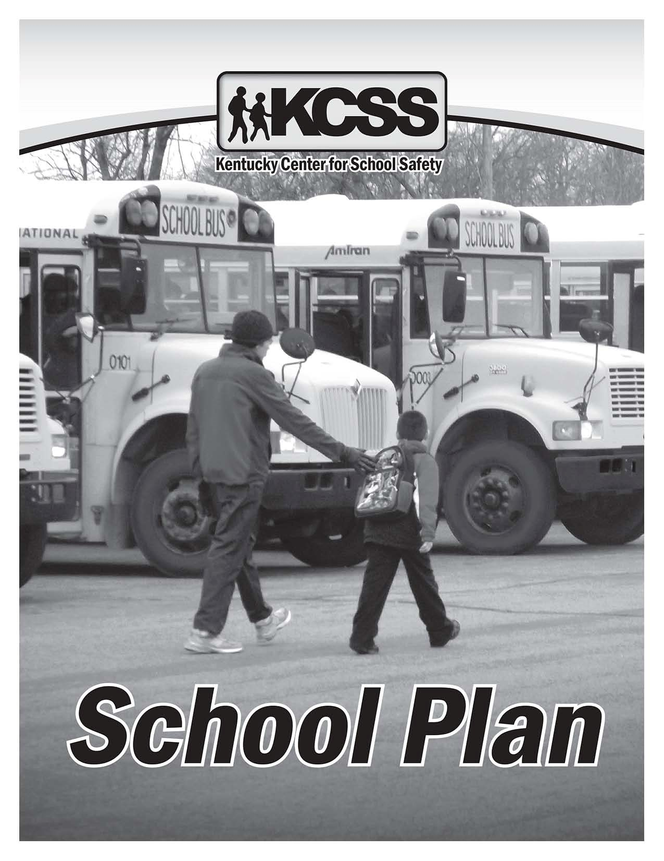
Emergency Management Resource Guide
Checklist for School Planning
School Plan
Under the direction of the principal, each school is to complete the following according to its unique needs and circumstances.
- Have each team member become familiar with this Emergency
Management Resource Guide
- Complete the following:
  - Cover Page for School-Centered Plan
  - Staff Skills Inventory (for Emergency Operations Planning)
  - Emergency Response Team Assignments
  - Students / Staff Needing Special Assistance: Teacher Survey
  - Students / Staff Needing Special Assistance: Master List
  - Classroom and Building “Hazard Hunt”
  - Classroom and Building “Hazard Hunt”: Master List (Mitigation Plan)
  - Assembly Area Outdoors, for Standard Evacuation
  - Off-Site Evacuation Location: Walking Distance
  - Off-Site Evacuation Location: Requiring Transport
  - School Accountability and Release
  - Schedule for Emergency Operations Training
  - Drill Schedule and Log
- Create an Emergency Team “Toolbox”
- Adopt Visitor Screening and Access Control Policies consistent with local board policy
- Adopt “age appropriate” Daily Dismissal Procedures consistent with
board policy
- Review the Emergency Response Protocols (“Response” section); make necessary modifications for school-specific needs (using feedback from
Staff Surveys and Emergency Team input, local or district phone numbers
and titles, etc.)
- Review and update Safe Weather Zones for each room of building
- Review and update Shelter in Place plan for each room of building
- Prepare your school’s Emergency Quick Reference Guide
- Provide Emergency Quick Reference forms to all staff members
- Establish a schedule and procedures for orientation, training, and practicing
the plan
- Submit the school’s Emergency Operations Plan to the superintendent or
designee and share with local first responders
- Practice the plan as scheduled, update the plan at least yearly

Creating the School Emergency Operations Plan
This section is designed to provide a practical step-by-step approach to forming an Emergency
Operations Plan. It addresses issues from team formation through submission of the plan to the
Superintendent’s Office. The first step in creating the Emergency Operations Plan is forming the Emergency Response Team. As introduced earlier, the team should represent the diverse training and expertise of the school community.
After the team is formed, the next step is for each team member to review this manual in its entirety.
Then using the forms provided in this chapter, create the Emergency Operations Plan. Next, the Emergency Response Team should conduct a presentation at a faculty/staff meeting to update the entire staff regarding Universal Emergency Procedures, Emergency Operations Protocols, Emergency Response Team assignments specific roles, etc. Finally, the team will submit a copy of the plan to the Superintendent’s Office.
Using this guide (as adapted by your District Support Team) as a starting point, each school and school support building is to establish an Emergency Response Team and is to develop (or update) an Emergency Operations Plan to include:
School Plan
- Clearly defined staff roles/responsibilities (Emergency Response Team, Incident Command System, etc.)
- Procedures for emergency evacuation, administering first aid, etc.
- Setting up a “Command Post”
- Establishing potential staging areas
- Student accounting and release procedures
- Assembly Areas
- Guidelines for communication with the media
- Establishing primary and back-up methods for communication (within school, with Central Office, and with parents and community)
Each Emergency Operations Plan shall be updated yearly and submitted to the Superintendent’s
Office, and shall reflect the actions required by all involved parties to minimize loss of life and injury to persons and property.
The school principal is responsible for supervising, monitoring, organizing the development and training staff on the school emergency operations plan. K.R.S. 158.162 requires that this training take place prior to students beginning classes.

Forming the Emergency Response Team
The school principal is responsible for overseeing the formation of the Emergency Response Team and is the designated leader.
A school’s Emergency Response Team should reflect the diversity of the school community and should capitalize on the unique training and expertise offered by staff in various positions in the school.
The purpose of the Emergency Response Team includes the following:
- Develop the school’s Emergency Operations Plan based upon documented school-specific risks, assets, and needs. This plan should use an all-hazards approach and be aligned with the District Plan. Conduct or coordinate orientation training for staff and recommend additional training.
School Plan
- Conduct or coordinate awareness programs for students.
- Evaluate the school’s preparedness for implementing specific emergency response protocols based upon the given situation.
- Report progress to the school’s site based council, parents, and superintendent.
- Assist with the completion of “After Action Review Report” (debriefs) following exercises and/ or an event.
Suggested Team Members
Principal
•
Counselor
•
Nurse
•
Head custodian or campus foreman
•
Office secretary
•
Vocational education teacher
•
Chemistry teacher
•
School security or law enforcement personnel
•
School psychologist
•
Social worker
•
Special education teacher
•
Transportation coordinator
•
Cafeteria Manager Personnel with areas of expertise (i.e., CPR, first
•
aid, etc.)
Staff located in strategic positions in the building (i.e., near exits or
•
fire extinguishers, on different floors, etc.)
School Teams may also consider community representatives such as
•
Police, Fire, Emergency Medical

◦
Social Service Agencies

◦
Mental Health

◦
Clergy

◦
Parents

◦
Local emergency response personnel

◦

Suggested Steps for Team Formation
- Principal communicates with all staff identifying specific needs, skills and training for assignment on the Emergency Response Team (see Staff Skills Inventory). Principal or designee creates list of interested staff, making sure all major areas of need are addressed, including:
  - Multilingual staff member
  - Physical/medical needs
  - Emotional/mental health needs
  - Students with special needs
  - Staff from all areas of the building (different floors, wings, out-buildings, etc.)
  - Staff with knowledge of transportation needs
  - Staff with knowledge of the building floor plan, locks, etc.
  - Staff with knowledge of community resources
School Plan
- A meeting is held with potential team members to discuss what will be expected for
team membership.
- Principal/facility director or designee follows-up with all staff to update on Team formation, and to fill in areas where deficits exist (NOTE: Although an individual may seem “perfect” for a role, no one should be required to have a primary position on an emergency team if he/ she does not feel capable of fulfilling his/her duties in time of need).
- An initial meeting is held to formally establish the Emergency Response Team, and to begin the process of developing the school’s Emergency Operations Plan.
- Conduct a formal presentation during a staff/faculty meeting at the beginning of each school year.
- Hold regular team meetings throughout the school year to review protocols and ongoing issues as they arise (may include local, state or national issues that may affect the school).
- Set dates to conduct orientation, review and updates of the plan.

ICS / Emergency Operations
Team Roles and Responsibilities
School Plan
The principal, as Incident Commander (IC) is in charge. As appropriate, the IC activates those in the
Incident Command System (ICS), who in turn, activate others needed to fulfill emergency response tasks.
Title | Role, Responsibility
Incident Command:  Principal | Responsible for development of school’s plan and overall management of emergency situations; establish/manage Command Post; activate ICS; determine strategies to implement protocols and adapt as needed
Safety Official:  Security,  Law Enforcement | Monitor safety conditions of an emergency situation and develop measures for ensuring the safety of building occupants (students, staff, volunteers, responders); document activities
Public Information  Official:  Media Liaison | Develop relationship with local media reps.; prepare media releases; establish “media center” near Command Post; coordinate information with Incident Commander and District Support Team; document activities
Liaison Official:  Liaison to Outside  Agencies | Develop working knowledge of local/regional agencies; serve as the primary on-scene contact for outside agencies assigned to an incident; assist in accessing services when the need arises; document activities
Planning/Intelligence:  Situation Analysis | Assist Incident Commander in the collection and evaluation of information about an incident as it develops (including site map and area map of related events); assist with ongoing planning efforts; maintain incident time log; document activities
Operations:  Student Accounting  and Release | Analyze school staffing to develop a Student Accounting and Release Plan  (accounting from individual teachers to Student Accounting and Release to  Command Post); implement plan in an emergency; document activities
Operations:  Facility and Environmental | Monitor site utilities (electric, gas, water, HVAC) shut off only if danger exists or directed by Incident Commander; assist in securing facility); document activities
Operations:  First Aid, CPR, Medical | Establish medical triage with staff trained in first aid, CPR; provide/oversee care given to the injured; distribute supplies (latex gloves, bandages, etc.); request additional supplies from Logistics; document activities
Operations:  Crisis Intervention  and Response | Provide and access psychological first aid services for those in need (working with “Operations: Medical”); access local/regional providers for ongoing crisis counseling for students, staff, parents; document activities
Operations:  Food, water, sanitation | Coordinate the rationed distribution of food and water (prolonged emergencies); establish secondary toilet facilities in the event of water or plumbing failure; request needed supplies from Logistics; document activities
Logistics:  Communications | Establish/oversee communications center and activities during an emergency (two-way radio, battery-powered radio, written updates, etc.); develop an automated notification system for after-hours communication; document activities
Logistics:  Supplies | Responsible to establish and maintain “Emergency Team Toolbox” (fresh batteries, etc.); coordinate access to and distribution of supplies during an emergency; monitor inventory of supplies and equipment; document activities
Administration and Finance:  Documentation | Responsible for overall documentation and record keeping activities; when possible, photograph or videotape damage to property; develop a system to monitor and track expenses and financial losses; secure all records

Cover Page for School-Centered Plan
Each school is responsible for creating and updating its Emergency Operations Plan on a yearly basis. This cover page should accompany the school’s completed plan according to the guidelines established by the District Support Team. The school principal needs to sign this cover prior to submitting the plan to the central office.
School Plan
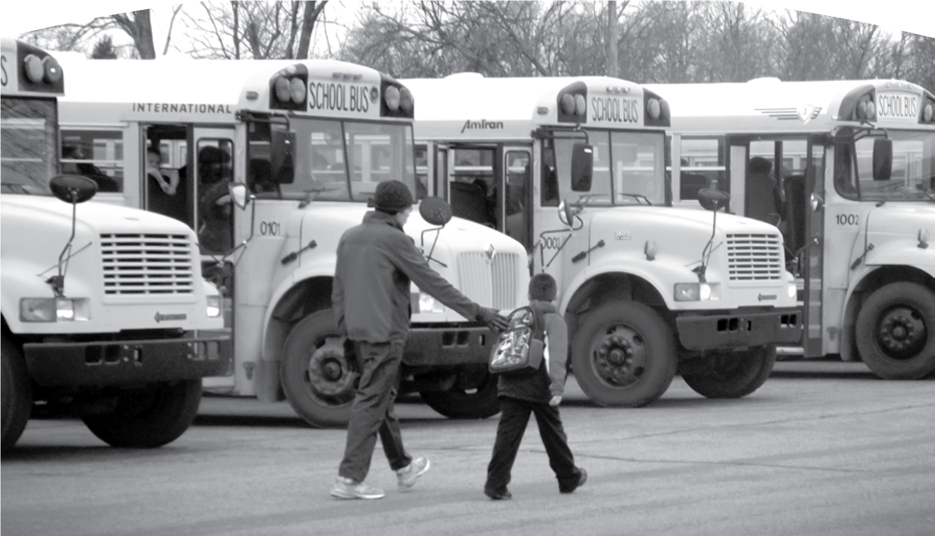
Emergency
Management
Response Plan
Model Middle School
Current Year

Dr. Ed Leadership

Principal Signature

Date

Kentucky Center for School Safety

Staff Skills Inventory
(for Emergency Operations Planning)
Staff: As part of the development of our Emergency Operations Plan, and in accordance with district policy, please complete the following survey and return to the administration office. The information provided will be used to help design and update our Emergency Operations Plan in order to be fully prepared for an emergency situation should one arise.
NAME: ROOM
I. Emergency Response:
Please check any of the following areas in which you have training or expertise:
First aid Search and rescue Counseling/mental health
_
CPR
_
AED
_
Hazardous materials
_
Firefighting
__
Emergency medical
_
Media relations

_
Incident debriefing
Explain or clarify items checked, if needed

II. Special Considerations:
School Plan
Please check and list special skills or resources you feel would be an asset in an emergency situation.
Explain items checked:
Multilingual, list language(s)
Experience with disabilities
Ham radio or CB radio experience
Knowledge of community resources
Other knowledge or skills
Other knowledge or skills

Emergency Response Team Assignments
In general, Incident Command System (ICS) or Emergency Response Team roles should be a logical, reasonable parallel to day-to-day work assignments. Complete the form below to reflect your school Emergency Response Team assignments (reference page 56 of the Emergency Management Resource Guide).
School Plan
Title | Name  Location and Numbers | Alternate Name Location and Numbers
Incident Command:
Principal
Safety Official:
Security, Law Enforcement
Public Information Official:
Media Liaison
Liaison Official:
Liaison to Outside Agencies
Planning/Intelligence:
Situation Analysis
Operations:
Student Accounting and Release
Operations:
Facility and Environmental
Operations:
First Aid, CPR, Medical
Operations:
Crisis Intervention and Response
Operations:
Food, water, sanitation
Logistics:
Communications
Logistics:
Supplies
Administration and Finance:
Documentation

Students / Staff Needing Special Assistance

TEACHER SURVEY
Instructions: Teachers are to fill in the name of any student in their class who will require special assistance in the event of an emergency (considering a variety of emergency conditions which may alter needs, such as severe weather, evacuation needs, hazardous materials, etc.):

Student/Staff Name Assistance Needed

____________________________________

____________________________________

____________________________________

School Plan
____________________________________

____________________________________

____________________________________

____________________________________

SIGNATURE:________________________ ROOM:_______________________

Students / Staff Needing Special Assistance

MASTER LIST
Using the information from individual Teacher/Staff Survey forms, the Emergency Response Team maintains a master list of students/staff needing special assistance in the event of an emergency. A designated collection point for these students should be established in conjunction with emergency responders. This should be done on each floor of the building.
Students/Staff Name Assistance Needed
School Plan
Individual to Provide Assistance
_____________________________ ________________________________________________
________________________________________________
________________________________________________
_____________________________ ________________________________________________
________________________________________________
________________________________________________
_____________________________ ________________________________________________
________________________________________________
________________________________________________
_____________________________ ________________________________________________
________________________________________________
________________________________________________
_____________________________ ________________________________________________
________________________________________________
________________________________________________
_____________________________ ________________________________________________
________________________________________________
________________________________________________
_____________________________ ________________________________________________
________________________________________________
________________________________________________
_____________________________ ________________________________________________
________________________________________________
________________________________________________

Classroom and Building “Hazard Hunt”
ALL STAFF Instructions: The Emergency Response Team is interested in identifying any special circumstances which exist in our school or near our campus which present unique problems or potential risk to persons or property. These may include materials used in classes, issues specific to your location in the building, situations which may impede evacuation from the building, community issues (factories, airport, water plant, rivers/streams), etc. Please describe any such potential hazards below, and actions requested to mitigate:
Potential Hazard Action Requested to
Mitigate the Hazard
_________________________________ __________________________________________
_________________________________ __________________________________________
_________________________________ __________________________________________

_________________________________ __________________________________________
_________________________________ __________________________________________
_________________________________ __________________________________________

_________________________________ __________________________________________
_________________________________ __________________________________________
_________________________________ __________________________________________

_________________________________ __________________________________________
_________________________________ __________________________________________
_________________________________ __________________________________________

_________________________________ __________________________________________
_________________________________ __________________________________________
_________________________________ __________________________________________

_________________________________ __________________________________________
_________________________________ __________________________________________
_________________________________ __________________________________________

School Plan
SIGNATURE: __________________________________ ROOM: ____________________________

Classroom and Building “Hazard Hunt”

MASTER LIST (Mitigation Plan)
Each Emergency Response Team is required to identify circumstances unique to its school/campus/ facility that present unique risks to persons or property. These may include materials used within the building, potentially troublesome evacuation routes, dangers due to geographic location, proximity to potentially hazardous buildings in the community, issues related to sharing a campus with another school, etc.
School Plan
Using information from “Classroom and Building ‘Hazard Hunt’ forms”, as well as insights from Emergency Response Team members, list below any specific risks or potential hazards needing special consideration and plans to address them (copy form as needed):

Potential Hazard | Action Needed to Mitigate the Hazard | Person Responsible | Date Completed

Assembly Area Outdoors,
for Standard Evacuation
Use the following worksheet to plan for evacuation from the building to an on-site or near-site Assembly Area (e.g., on-site football field). The Assembly Area should minimize exposure of students to dangers or hazards around the school.
- Examine floor plans, site plans and maps for your school grounds and surrounding neighborhood. Determine primary and secondary exits for each room in the building. Consider factors such as: gas, sewer, power lines, chain link fences (electrical hazard), facilities containing hazardous materials, water towers, multiple story buildings (vulnerable to collapse), transformers, balconies (which may fall from buildings), etc.
- Designate each of the following in the Assembly Area:
Command Post
Access for emergency vehicles
Student assembly areas (by grade level or team, etc.) ___________________________________
_____________________________________________________________________________
_____________________________________________________________________________
_____________________________________________________________________________
_____________________________________________________________________________
_____________________________________________________________________________
_____________________________________________________________________________
_____________________________________________________________________________
_____________________________________________________________________________
_____________________________________________________________________________
School Plan
First aid area
Psychological first aid area
Student release
Media area
- Communicate Student Accounting and Release procedures to parents.

Off-Site Evacuation Location:
Walking Distance
In inclement weather, it may be necessary to move students to an Off-Site Location rather than using the typical Outdoor Assembly Area. Use the following worksheet to plan for evacuation from the building to an Off-Site Evacuation location within walking distance from the school. Coordinate your planning with Central Office, other schools, etc.
- Examine maps and site plans for possible Alternate Building Location in the immediate vicinity of the school property.
- Consider factors such as roadways, waterways, power lines, metal fences, utilities, etc., and select routes that minimize exposure to area hazards.
- Coordinate planning with nearby schools, community centers, businesses, churches, etc. to establish relationships for Off-Site Evacuation Locations and secure MOUs.
- Designate each of the following:
Alternate Building Location Lead Contact / Phone

School Plan

(Address)
Secondary Location Lead Contact / Phone

(Address)
USE SPACE BELOW for any special planning needs, routes, alternate routes, or for coordinating your school’s plan with other schools or buildings on the same campus.
___________________________________________________________________________________
___________________________________________________________________________________
___________________________________________________________________________________
___________________________________________________________________________________
___________________________________________________________________________________
Off-Site Evacuation Location:
Requiring Transport
Use the following worksheet to plan for evacuation from the building to an Off-Site Evacuation location requiring transport from the school. Coordinate your planning with Central Office, other schools, etc.
- Contact Director of Transportation in Central Office to coordinate and plan for transporting students and staff to an Off-Site Evacuation Location. Examine local area maps for primary and secondary roadways to transport students and staff to an Off-Site Evacuation Location.
- Consider factors such as roadways (for potential traffic “gridlock”), waterways, power lines, metal fences, utilities, etc., and select routes that minimize exposure to area hazards.
- Coordinate planning with other schools, community centers, businesses, churches, etc. to establish
a MOU for Off-Site Evacuation Locations (schools across town may serve as alternate site for
each other).
- Designate each of the following:
Off-Site Evacuation Location Lead Contact / Phone

School Plan

(Address)
Secondary Location Lead Contact / Phone

(Address)
USE SPACE BELOW for any special planning needs or for coordinating your school’s plan with other schools or buildings on the same campus.
___________________________________________________________________________________
___________________________________________________________________________________
___________________________________________________________________________________
___________________________________________________________________________________
___________________________________________________________________________________

School Accountability and Release
Each school needs to establish a specific plan for school accountability and release. Use the following worksheet to describe how your school will account for students, staff, visitors and other persons in the building in the event of an evacuation. If Wi-Fi is not available, a paper copy of the names of students and staff should be available.
- List below steps or procedures staff will take to assure school accountability and release (i.e., teachers report to team leader, who reports to “School Accountability and Release” member of the school’s Emergency Response Team, who reports to principal):
________________________________________________________________________________
________________________________________________________________________________
________________________________________________________________________________
________________________________________________________________________________
________________________________________________________________________________
________________________________________________________________________________
________________________________________________________________________________
________________________________________________________________________________
________________________________________________________________________________
________________________________________________________________________________
________________________________________________________________________________
________________________________________________________________________________
School Plan
- What procedures will be in place to release students to parents, guardians, or other designated adults during an emergency?
________________________________________________________________________________
________________________________________________________________________________
________________________________________________________________________________
________________________________________________________________________________
________________________________________________________________________________
________________________________________________________________________________
________________________________________________________________________________
________________________________________________________________________________
________________________________________________________________________________
________________________________________________________________________________
________________________________________________________________________________
________________________________________________________________________________

Schedule for Emergency
Operations Training
School Plan
Each school should prepare a schedule of emergency operations training annually. You may also use the worksheet below to outline a schedule for training events, drills, etc.
Month | Training Event and Who is to be Trained | Person Responsible | Comments
July
August
September
October
November
December
January
February
March
April
May
June

Drill Schedule and Log
Special note: As of 2013, all four emergency response drills (fire, lockdown, severe weather and earthquake) must be conducted within the first 30 days of the new school year and must be conducted again in January (see Appendix D: Kentucky Department of Education Guidance For: Senate Bill 8/ House Bill 354 Emergency Management Planning For Schools and Districts).
Use the following worksheet to plan drills for your school. Submit a copy of the schedule with your school’s plan, and use the original to document drills when they actually occur.
Fire Drills: Two fire drills in the first month of school, and one per month each following month.
School Plan
Monthly Schedule | Date Conducted | Weather Conditions | Number of Occupants | Evacuation Time | Comments, Notes
1st:
2nd:
3rd:
4th:
5th:
6th:
7th:
8th:
9th:
10th:
11th:
12th:
Earthquake Drills:
Date Scheduled | Date Conducted | Number of Occupants | Response Time | Comments, Notes
1st:
2nd (Jan):
Severe Weather Safe Area:
Date Scheduled | Date Conducted | Number of Occupants | Response Time | Comments, Notes
1st:
2nd (Jan):
Lockdown:
Date Scheduled | Date Conducted | Number of Occupants | Response Time | Comments, Notes
1st:
2nd (Jan):

Emergency Team “Toolbox”
Each school’s Emergency Response Team should consider developing a “toolbox” to have available for use during an emergency situation. Items in the toolbox should not be used for anything other than emergency preparedness training activities. A member of the Emergency Response Team should be assigned to keep the toolbox updated (change batteries, update phone numbers, etc.). The toolbox should be portable and readily accessible for use in an emergency.
Copies of the all forms completed in the development of the school or
❑
facility Emergency Response Plan (Chain of Command, Students Needing
Assistance, etc.)
Map of building(s) with location of Exits, Phones, First Aid Kits, Assembly Areas
❑
Blueprints of school building(s), including utilities
❑
Record (video) inside and outside of the building and grounds
❑
Map of local streets with evacuation route (Off-Site Evacuation Location
❑
requiring Transport)
Flash lights (recommend the type that does not require batteries)
❑
First aid kit and latex gloves (and other types for latex-sensitive persons)
❑
Faculty/staff roster (including emergency contacts)
❑
Student roster (including emergency contacts for parents)
❑
Safety Data Sheet (SDS)
❑
Two-way radios and/or cellular phones available
❑
Battery powered AM/FM radio and spare batteries (wind-up radios)
❑
Several legal pads and ink pens
❑
Grease boards and markers (or dry erase boards)
❑
White peel-off stickers and markers (for name tags use permanent markers)
❑
Local telephone directory
❑
Lists of the district personnel’s contact list
❑
Lists of other emergency phone numbers
❑
Other
❑

Other
❑

Other
❑

School Plan

